Read the data set Housing.csv, has columns as below
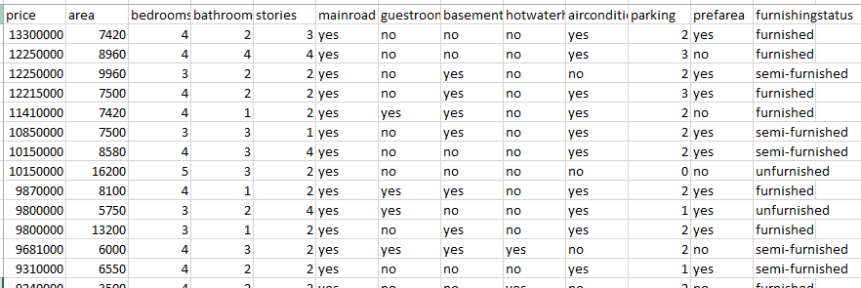

Which feature in the dataset is most likely to be used as the target variable in a regression tree model?
Which of the following features is categorical and would need to be encoded before training a decision tree?
What is the purpose of setting the 'max_depth' hyperparameter in a DecisionTreeRegressor?
Which metric does a DecisionTreeRegressor use to evaluate the quality of a split?
If a regression tree predicts the same value for multiple house sizes, what does this indicate?

Project
Data preprocessing
Feature encoding
Model training
Hyperparameter tuning
Tree visualization
MSE evaluation
Depth impact analysis

Predicting House Prices with Decision Tree Regression

Use a decision tree regressor to predict house prices based on features like area, bedrooms, bathrooms, and amenities. Explore how tree depth affects predictions and how MSE guides split decisions.
Identify which features were one-hot encoded and why.
Try different max_depth values and observe how predictions change.
Manually compute MSE for a few predictions and compare with mean_squared_error.
Use the tree plot to explain how splits were made and what values were predicted.
Discuss how depth affects bias and variance in this dataset
Use .feature_importances_ to rank features and interpret their impact.

